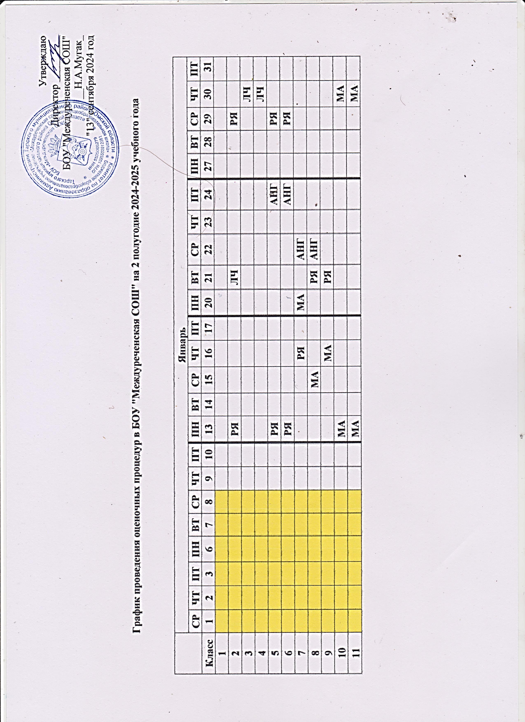

|  |  |  |  |  |  |  |  |  |  |  |  |  |  |  |  |  |  |  |  |  |
| --- | --- | --- | --- | --- | --- | --- | --- | --- | --- | --- | --- | --- | --- | --- | --- | --- | --- | --- | --- | --- |
|  | **Февраль** | | | | | | | | | | | | | | | | | | | |
| **ПН** | **ВТ** | **СР** | **ЧТ** | **ПТ** | **ПН** | **ВТ** | **СР** | **ЧТ** | **ПТ** | **ПН** | **ВТ** | **СР** | **ЧТ** | **ПТ** | **ПН** | **ВТ** | **СР** | **ЧТ** | **ПТ** |
| **Класс** | **3** | **4** | **5** | **6** | **7** | **10** | **11** | **12** | **13** | **14** | **17** | **18** | **19** | **20** | **21** | **24** | **25** | **26** | **27** | **28** |
| **1** |  |  |  |  |  |  |  |  |  |  |  |  |  |  |  |  |  |  |  |  |
| **2** |  |  | **МА** |  |  |  |  |  | **ЛЧ** |  | **РЯ** |  |  |  |  |  |  |  |  |  |
| **3** |  |  |  |  |  |  | **МА** |  |  |  |  |  |  |  |  |  |  |  |  |  |
| **4** |  |  |  | **МА** |  |  |  |  |  |  |  |  |  |  |  |  |  |  |  |  |
| **5** |  |  |  |  |  |  |  |  | **ТРУД** |  |  | **РЯ** | **АНГ** |  |  |  |  |  |  |  |
| **6** |  |  |  |  |  |  |  |  |  |  | **РЯ** |  | **АНГ** |  |  |  | **ТРУД** |  |  |  |
| **7** |  |  |  | **МА** |  |  |  |  | **РЯ** |  |  |  |  |  | **АНГ** |  | **ТРУД** |  |  |  |
| **8** |  |  | **МА** |  |  |  |  | **РЯ** |  |  |  |  |  |  | **АНГ** |  | **МА** |  |  |  |
| **9** |  |  | **МА** |  |  |  |  |  |  |  |  | **РЯ** |  |  |  |  | **МА** |  |  |  |
| **10** |  |  |  | **РЯ** |  |  |  |  |  |  | **МА** |  |  |  |  |  |  |  |  |  |
| **11** |  | **ЛИТ** |  |  |  |  |  |  |  |  | **МА** |  |  |  |  |  |  |  |  |  |

|  |  |  |  |  |  |  |  |  |  |  |  |  |  |  |  |  |  |  |  |  |  |
| --- | --- | --- | --- | --- | --- | --- | --- | --- | --- | --- | --- | --- | --- | --- | --- | --- | --- | --- | --- | --- | --- |
|  | **Март** | | | | | | | | | | | | | | | | | | | | |
| **ПН** | **ВТ** | **СР** | **ЧТ** | **ПТ** | **ПН** | **ВТ** | **СР** | **ЧТ** | **ПТ** | **ПН** | **ВТ** | **СР** | **ЧТ** | **ПТ** | **ПН** | **ВТ** | **СР** | **ЧТ** | **ПТ** | **ПН** |
| **Класс** | **3** | **4** | **5** | **6** | **7** | **10** | **11** | **12** | **13** | **14** | **17** | **18** | **19** | **20** | **21** | **24** | **25** | **26** | **27** | **28** | **31** |
| **1** |  |  |  |  |  |  |  |  |  |  |  |  |  |  |  |  |  |  |  |  |  |
| **2** |  |  |  |  |  |  | **ОКМ** |  | **МА** | **АНГ** |  | **РЯ** | **ЛЧ** |  |  |  |  |  |  |  |  |
| **3** |  |  |  |  |  |  | **ОКМ** |  | **ЛЧ** | **АНГ** |  | **МА** | **РЯ** |  |  |  |  |  |  |  |  |
| **4** |  |  |  |  |  |  | **ОКМ** | **ЛЧ** |  | **АНГ** |  | **МА** | **РЯ** |  |  |  |  |  |  |  |  |
| **5** |  |  |  | **ГЕО** |  |  | **БИО** |  | **МА** | **АНГ** | **ИЗО** | **РЯ** |  | **ТРУД** |  |  |  |  |  |  |  |
| **6** | **ГЕО** |  |  | **ИЗО** |  |  |  | **АНГ** | **МА** | **БИО** | **РЯ** | **ТРУД** | **ИНФ** |  |  |  |  |  |  |  |  |
| **7** |  |  | **ГЕО** | **ИЗО** |  |  | **ТРУД** | **МА** | **ИНФ** | **БИО** | **АНГ** | **РЯ** | **ФИЗ** |  |  |  |  |  |  |  |  |
| **8** |  |  | **ЛИТ** |  |  |  |  | **РЯ** | **БИО** | **ТРУД** | **АНГ** | **ФИЗ** | **МА** | **ХИМ** |  |  |  |  |  |  |  |
| **9** |  |  |  | **ГЕО** |  | **ТРУД** |  | **БИО** | **ЛИТ** |  | **МА** | **РЯ** | **ФИЗ** | **ХИМ** |  |  |  |  |  |  |  |
| **10** |  | **МА** |  |  |  |  |  | **ФИЗ** | **РЯ** |  |  |  |  | **МА** |  |  |  |  |  |  |  |
| **11** |  | **МА** |  |  |  |  | **ЛИТ** |  | **ФИЗ** |  |  |  | **ОБЩ** | **МА** |  |  |  |  |  |  |  |

|  |  |  |  |  |  |  |  |  |  |  |  |  |  |  |  |  |  |  |  |  |  |  |
| --- | --- | --- | --- | --- | --- | --- | --- | --- | --- | --- | --- | --- | --- | --- | --- | --- | --- | --- | --- | --- | --- | --- |
|  | **Апрель** | | | | | | | | | | | | | | | | | | | | | |
| **ВТ** | **СР** | **ЧТ** | **ПТ** | **ПН** | **ВТ** | **СР** | **ЧТ** | **ПТ** | **ПН** | **ВТ** | **СР** | **ЧТ** | **ПТ** | **ПН** | **ВТ** | **СР** | **ЧТ** | **ПТ** | **ПН** | **ВТ** | **СР** |
| **Класс** | **1** | **2** | **3** | **4** | **7** | **8** | **9** | **10** | **11** | **14** | **15** | **16** | **17** | **18** | **21** | **22** | **23** | **24** | **25** | **28** | **29** | **30** |
| **1** |  |  |  |  |  |  |  |  |  |  |  |  |  |  |  |  |  |  | **СМЧ** | **ФРА** | **ИЗО** | **ТРУД** |
| **2** |  |  | **РЯ** |  |  |  |  |  |  |  |  | **МА** | **ЛЧ** |  |  | **РЯ** |  |  | **СМЧ** | **ФРА** | **ИЗО** | **ТРУД** |
| **3** |  |  |  |  |  |  |  |  |  |  | **МА** |  |  | **ЛЧ** |  |  |  |  | **СМЧ** | **ФРА** | **ИЗО** | **ТРУД** |
| **4** |  |  |  |  |  |  | **МА** |  |  |  |  |  |  |  |  |  | **ТРУД** | **РЯ** |  | **ФРА** | **ОКМ** | **МА** |
| **5** |  |  |  |  | **РЯ** |  | **АНГ** |  |  |  |  |  | **ОП** | **ИСТ** |  | **ФРА** | **МУЗ** | **ГЕО** |  | **РЯ** | **ОДНР** | **АНГ** |
| **6** |  |  |  | **РЯ** |  |  | **АНГ** |  |  |  |  | **МУЗ** |  | **БИО** |  |  | **ОБЩ** |  | **РЯ** | **ФРА** | **ИСТ** | **АНГ** |
| **7** |  |  |  | **АНГ** |  | **РЯ** |  | **МА** |  |  |  | **ОБЩ** | **ВЕР** | **БИО** | **АНГ** |  | **ИНФ** | **ИСТ** |  | **ЛИТ** | **РЯ** | **ФГ** |
| **8** |  |  |  |  |  |  | **РЯ** | **МА** | **АНГ** | **ОБЗР** | **ФИН** |  | **ФГ** | **ФРА** | **БИО** | **ОБЩ** | **МУЗ** | **ИНФ** | **РЯ** | **ТРУД** | **ФИЗ** | **АНГ** |
| **9** |  |  |  | **НЕМ** |  | **МА** |  |  | **РЯ** |  |  | **ОБЗР** | **ВЕР** |  |  | **ХИМ** | **НЕМ** | **ЛИТ** | **ФРА** | **ФИН** | **ИНФ** | **ИСТ** |
| **10** |  | **МА** |  |  |  |  | **НЕМ** |  |  |  |  | **ФРА** | **ОБЗР** | **МА** |  | **ОБЩ** | **ФИЗ** | **ВЕР** |  | **ИНФ** | **ИСТ** | **НЕМ** |
| **11** |  | **МА** | **НЕМ** |  |  |  |  |  |  |  |  | **ФРА** | **ОБЗР** | **МА** |  | **ХИМ** | **НЕМ** | **ФИЗ** | **ИНФ** |  | **РЯ** | **ВЕР** |

|  |  |  |  |  |  |  |  |  |  |  |  |  |  |  |  |  |  |  |  |  |  |  |
| --- | --- | --- | --- | --- | --- | --- | --- | --- | --- | --- | --- | --- | --- | --- | --- | --- | --- | --- | --- | --- | --- | --- |
|  | **Май** | | | | | | | | | | | | | | | | | | | | | |
| **ЧТ** | **ПТ** | **ПН** | **ВТ** | **СР** | **ЧТ** | **ПТ** | **ПН** | **ВТ** | **СР** | **ЧТ** | **ПТ** | **ПН** | **ВТ** | **СР** | **ЧТ** | **ПТ** | **ПН** | **ВТ** | **СР** | **ЧТ** | **ПТ** |
| **Класс** | **1** | **2** | **5** | **6** | **7** | **8** | **9** | **12** | **13** | **14** | **15** | **16** | **19** | **20** | **21** | **22** | **23** | **26** | **27** | **28** | **29** | **30** |
| **1** |  |  |  | **ОКМ** |  |  |  |  | **РЯ** | **ЛЧ** | **МА** | **МУЗ** |  |  |  |  |  |  |  |  |  |  |
| **2** |  |  |  | **ОКМ** | **АНГ** |  |  |  | **РЯ** | **ЛЧ** | **МА** | **МУЗ** |  |  |  |  |  |  |  |  |  |  |
| **3** |  |  |  | **ОКМ** | **АНГ** |  |  |  | **РЯ** | **ЛЧ** | **МА** | **МУЗ** |  |  |  |  |  |  |  |  |  |  |
| **4** |  |  |  | **ОРКСЭ** | **АНГ** |  |  |  | **ИЗО** | **ЛЧ** |  |  |  |  |  |  |  |  |  |  |  |  |
| **5** |  |  |  | **БИО** |  |  |  |  | **ЛИТ** | **МА** | **ТРУД** | **ФГ** |  |  |  |  |  |  |  |  |  |  |
| **6** |  |  | **ГЕО** |  | **ЛИТ** |  |  | **ОДНР** | **ТРУД** | **МА** | **ФГ** |  |  | **РЯ** |  |  |  |  |  |  |  |  |
| **7** |  |  | **ФРА** |  | **ГЕО** |  |  | **МУЗ** | **ТРУД** | **ФИЗ** | **МА** | **ВДС** |  |  |  |  |  |  |  |  |  |  |
| **8** |  |  | **ВЕР** | **ГЕО** | **ЛИТ** |  |  |  | **ИСТ** | **ХИМ** | **МА** | **ТРУД** |  |  |  |  |  |  |  |  |  |  |
| **9** |  |  |  | **ГЕО** | **ФИЗ** |  |  |  | **РЯ** | **БИО** | **МА** | **ОБЩ** |  |  |  |  |  |  |  |  |  |  |
| **10** |  |  |  | **ХИМ** | **МА** |  |  |  | **ЛИТ** | **ГЕО** | **РЯ** | **БИО** |  |  |  | **МА** |  |  |  |  |  |  |
| **11** |  |  |  | **ГЕО** | **МА** |  |  |  | **ЛИТ** | **ИСТ** | **БИО** | **ОБЩ** |  |  |  | **МА** |  |  |  |  |  |  |

Условные обозначения

|  |  |
| --- | --- |
| ***Русский язык*** | РУ |
| ***Литературное чтение / литература*** | ЛЧ/ЛИТ |
| ***Окружающий мир*** | ОКМ |
| ***Математика*** | МА |
| ***Информатика*** | ИНФ |
| ***Музыка*** | МУЗ |
| ***Изобразительное искусство*** | ИЗО |
| ***Физическая культура*** | ФРА |
| ***Труд (технология)*** | ТЕХ |
| ***Физика*** | ФИЗ |
| ***Химия*** | ХИМ |
| ***История*** | ИСТ |
| ***Обществознание*** | ОБЩ |
| ***Иностранный язык*** | АНГ/НЕМ |
| ***География*** | ГЕО |
| ***Биология*** | БИО |
| ***Великие достижения соотечественников*** | ВДС |
| ***Основы безопасности и защита Родины*** | ОБЗР |
| ***Функциональная грамотность*** | ФГ |
| ***Вероятность*** | ВЕР |
| ***Финансовая грамотность*** | ФИН |
| ***Основы духовно-нравственной культуры народов России*** | ОДНР |
| ***Основы религиозных культур и светской этики*** | ОРКС |
| ***Основы программирования*** | ОП |
|  | |
| Каникулы |  |
| Промежуточная аттестация |  |
| ВПР |  |